Permission file
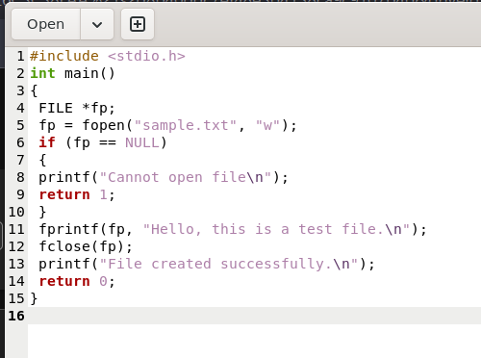
- Read and Write only to the owner
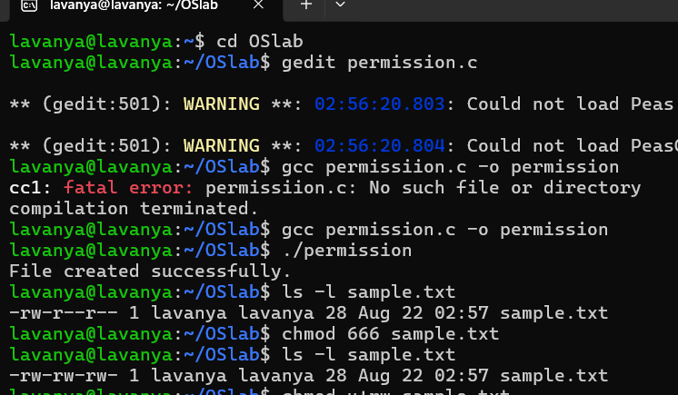

- Read and Write to the owner and group
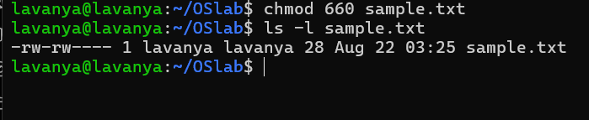
- Only owner can read and write
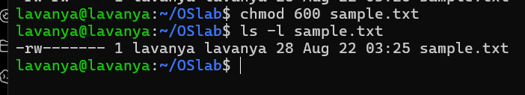
- Owner read/write, everyone else read-only
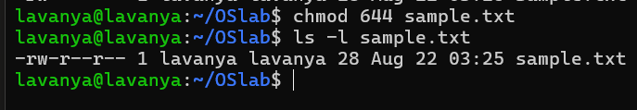
- Owner can do everything, others can only read and execute
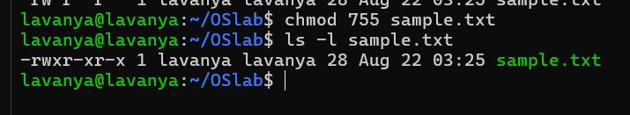
- Owner and group can read/write
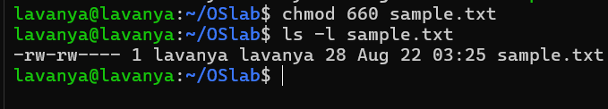
- Only owner can execute

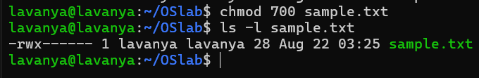
- Owner: read + write; Group: nothing; Others: nothing →600
- Owner: read + write; Group: read; Others: read → 644
- Owner: read + write + execute; Group: read + execute; Others: read + execute → 755
- Owner: read + write; Group: read + write; Others: nothing → 600
- Everyone: read only → 444

